**Application working model UI**At first run the command **npm install** to get all the packages ready, then run the command **npm run start** and login the application using **username: admin** and **password: admin**, or register with new username and password**.  
  
Login Page  
  
New user registration page:  
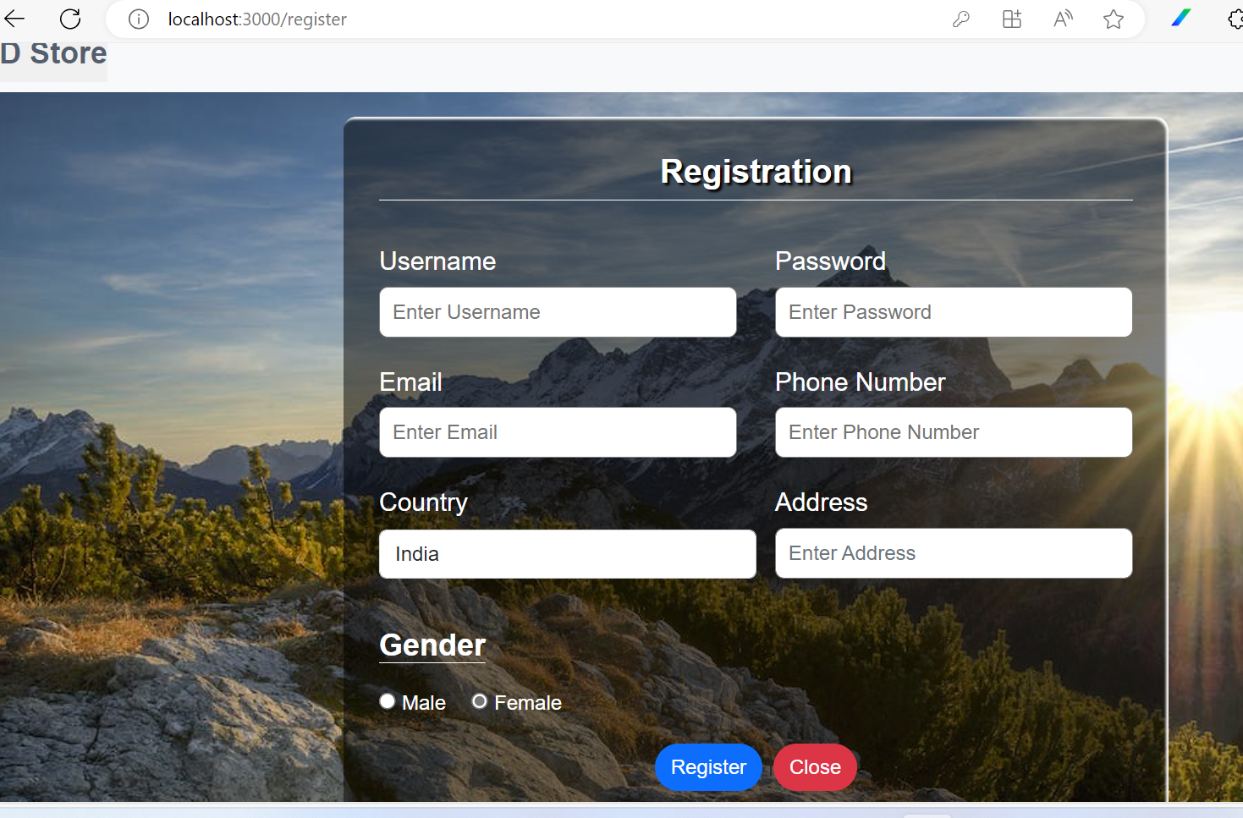  
  
Forgot password page:  
  
After login home page  
  
Products listing and filtering page:  
  
View details of each product:  
  
Cart count updated based on product addition:  
  
View cart items and checkout page  
**